Collection (JAVA) Notes

Define:

* In Java Collection is a framework that provides an Architecture for restoring and Manipulation.
* In Java Collection can do the operations on the data that is insertion, sort, remove, add, etc.
* Collection means Single unit of an Object(It is Single unit of an Object ).
* Collection Provides many of interface like set, list, queue etc.
* Collection also provides some classes like ArrayList, LinkedList, Vectors, HashSet, LinkedHashSet, TreeSet, PriorityQueue etc.

Que. What is Framework?

Ans:-

* In java It provides ready made Architecture.
* It means already existence of classes and interfaces.

Hierarchy Of Framework🡪

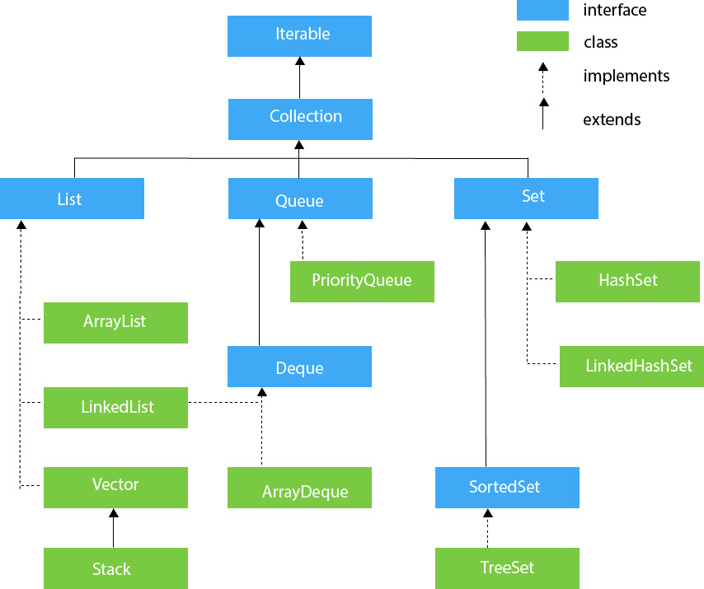

List Interface:-

* It is an interface which is inside the collection framework.
* In List interface there is implemented classes e.g. ArrayList, LinkedList, Vector.
* In List interface the order of insertion is always preserve.
* And the default capacity is 10 may be.

1. ArrayList:-

* In java ArrayList class use dynamic array to sort and remove the data.
* In ArrayList we can insert duplicate value.
* Order of insertion is maintain.
* Default capacity of ArrayList is 10.
* And it is

1. Vector:-
2. LinkedList:-

Selenium:

WebDriver:

* Compact Object Oriented API.
* Selenium WebDriver refers to both the language bindings and the implementations of the individual browser controlling code. This is commonly referred to as just *WebDriver*.

W3C:

* The W3C is an international community that works to develop Web standards.
* W3C do :-Major browser vendors (Mozilla, Google, Apple, Microsoft) support WebDriver and work constantly to improve the browsers and browser controlling code, which leads to a more uniform behaviour across the different browsers, making your automation scripts more stable.

url : //https://www.selenium.dev/documentation/grid/